1. Links with images

"Pink Frag Event Organizer" serves the best in providing all kinds of services in events managing sector. Joyce planned to create an official website to improve the standards of the organization to the next level of business increasing the customer interaction.  
  
She wanted to include a quick glimpse of the facts regarding the services offered by the company. The webpage with detailed notes and pictures should open when the customer clicks on the facts he/she is interested in. Let us help her in using image tags and link tags in the official web page of the organization.

Hints :

Tag <a> The <a> tag defines a hyperlink, which is used to link from one page to another.

Syntax : <a href = "#">...</a>

 Tag <img> The <img> tag defines an image in an HTML page.

Syntax : <img src = "xxx.png" >

Content :  
Home.html  
<h1> - Pink Frag Event Organizer  
<hr>

img tag id -imgHome ,src -home.jpg,width-500px,height-300px  
<h2> - Wedding  
<h3> - Make your D-day a fresh and cherishable memory to you and your loved ones  
 <p> - Pink Frog Event Organizer loves creating breath-taking, personal and luxurious weddings where every exquisite detail is   
<a> - more..  
<h2> - Corporate Events  
<h3> - Leave a permanent mark in the industry..  
 <p>We provide a business facilitation platform through well-researched content, which reflects the latest market trends  
<a> - more..  
<h2> - Birthday Party  
<h3> - Get ready for the bash..  
<p>Planning a birthday party? Whether a wild party with friends or a crazy party for the kids  
<a> -more..  
The  Header tags should be placed in the center  
  
Weddings.html  
<h2> - WEDDINGS  
<hr>  
<p> - Pink Frog Event Organizer loves creating breath-taking, personal and luxurious weddings where every exquisite detail is beautifully presented.  
Our passionate team of wedding experts are meticulous in ensuring that every aspect of the day is seamlessly stylish, from our delectable menus to glorious flowers, venue finding and dressing, production and entertainment.  
img tag id -imgWedding ,src -wedding.jpg,width-800px,height-400px  
CorporateEvents.html  
<h2>CONFERENCES  
 <hr>  
 <p> - We provide a business facilitation platform through well-researched content, which reflects the latest market trends and developments.  
Our conferences are designed to meet the ever-changing needs of the customer, with the goal of bringing industry professionals together to share their expertise, exchange ideas and facilitate business.  
The most important and valuable part of a corporate requirement is its Sales and that's coming by Brand Establishing, Promotions, Business Meet, Exhibitions and also uplifting the current profile. Get in touch with us for professional solution for your event.  
img tag id -imgCorporate ,src -Corporate.jpg,width-800px,height-400px  
SocialGatherings.html  
<h2>WHAT HAVE YOU PLANNED FOR YOUR BIRTHDAY??  
<h3>Just let us know, we will take care of the rest.  
<hr>  
<p>Planning a birthday party? Whether a wild party with friends or a crazy party for the kids,Most importantly, Pink Frag Event Organizer helps you gather that ever important catering services will be arranged as per your requirements and budget.  
Engage your guests in variety of events.  
Host the party with a lively anchor.  
img tag id -imgBirthday​​​​​​​ ,src -birthday.jpg​​​​​​​​​​​​​​​​​​​​​,width-800px,height-400px  
  
Constraints :  
Tag 'a' must be present minimum 3 times in the html page.  
The links to the other pages must be properly set.  
The Content in the tags should be the same as given in the problem content.  
Image tag as well as id and src for the image tag must be given as given in the problem content.

Note :

The Webpage should be present as shown in the screenshot.​​​​​​​  
Content of the page should be present as shown in the screenshot.  
Kindly refer the content which is given as a part of description  
  
Sample Screenshot 1 :  
  
Home.html  
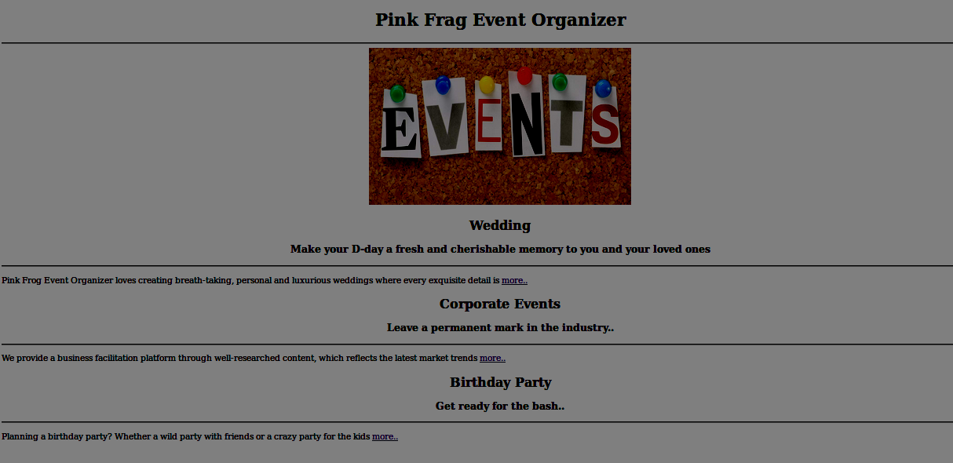  
  
Sample Screenshot 2 :  
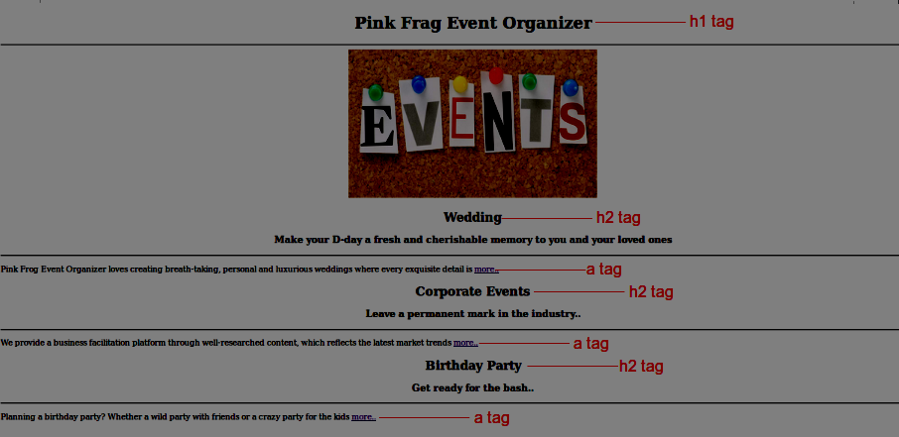  
  
  
Sample Screenshot 3 :  
  
Weddings.html  
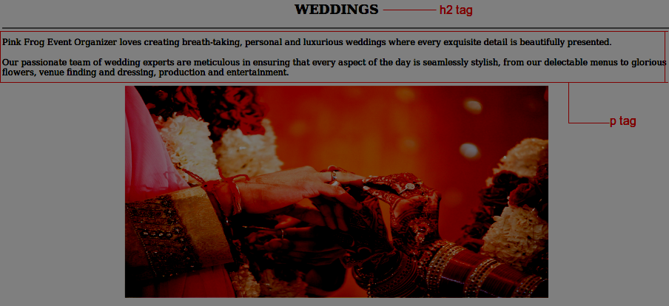  
  
Sample Screenshot 4 :  
  
CorporateEvents.html  
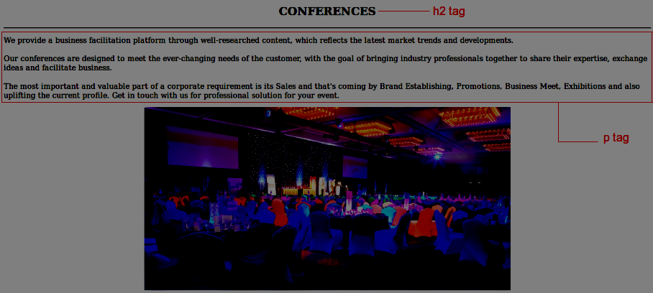  
  
Sample Screenshot 5 :  
  
SocialGatherings.html  
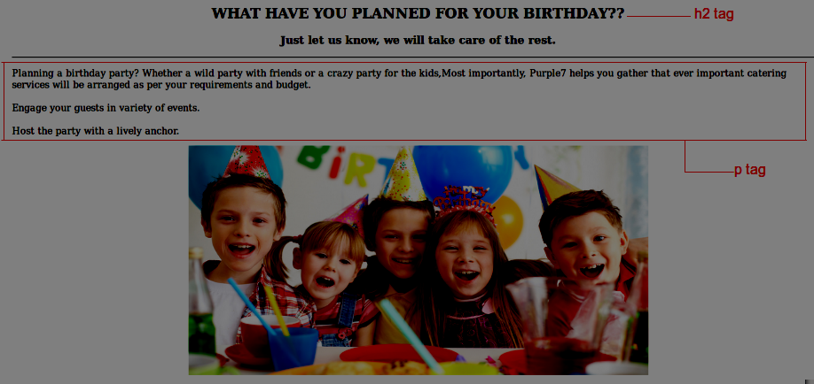

2.Links - referring to same page

Bella is undertaking an online course based on HTML concepts offered by Axcent Academy. As she has successfully completed the learning and exercises on the basics of html links, she started to learn the additional concepts covering the usage of anchor attributes.  
  
Her tutor assigned a practice exercise, in that exercise she has to create a web page for an Event Management Company with several hyperlinks representing the details. On clicking each link in the web page, it should display respective contents inside the respective div elements onthe same page as mentioned below. Let us help Bella to finish the task using the image tags and link tags available in html.

Hints :

Tag <a>

The <a> tag defines a hyperlink, which is used to link from one page to another.

Syntax : <a href = "#">...</a>

Tag <img>

The <img> tag defines an image in an HTML page.

Syntax : <img src = "xxx.png" >

Tag <div>

The <div> tag defines a division or a section in an HTML document. The <div> tag is used to group block-elements to format them with CSS.

Syntax : <div id = "xxx"></div>

Content :  
h1 - Pink Frag Event Organizer  
a tag with value - Wedding Event and href attribute 'Weddings'  
a tag with value - Corporate Event and href attribute 'CorporateEvents'  
a tag with value - Birthday party and href attribute 'BirthdayParty'  
h2 - EVENTS & PROMOTIONS  
img src - Event_Picture.jpg  
h3 - OUR WORK  
p - Our company's core objective is, simply but, to be good.  
            Built on the principles of transparency and accountability, we work dedicatedly on designing be spoke solutions that are creative, feasible, efficient, meticulously planned and successfully implemented.  
            We offer a range of solutions from product launches, gala dinners & conferences to theme nights, fashion shows, hostesses & models.  
            Our events team handles all your requirements from conceptualization to execution, leaving you free to focus completely on achieving your objectives. With proper planning and logistics management and the ability to activate requisite resources, we have undertaken a wide variety of projects. Our professional operations team will manage every aspect of your event, from invitations and RSVPs, branding, sound, light and technical solutions, to local and international entertainment and event staff. With dedicated suppliers in place we are able to handle any event requirement our clients may have.  
            Our specialized promotions department specifically focuses on providing clients with promoters, hostesses and models for marketing campaigns, events, exhibitions and fashion shows. We provide complete services covering selection, casting, training, supervision and reporting.  
  
div tag with id 'Weddings'  
h2 - Weddings  
img src - Wedding.jpg ,id -Wedding_Image  
h3 - Make your D-day a fresh and cherishable memory to you and your loved ones.  
p - We intricately craft each and every proceedings of your wedding , be it a Christian nuptials or a Hindu vivaha or a Muslim nikkah. Our experts have hands on experience in bringing your dreams to life , right from wedding cards design till the return gifts to the guests.  
                Wedding is your day to indulge in pure love and happiness..Don't make it the day for your peak of tensions and hassles. We, as the leading wedding planners in the town ,listen to and understand your budget and expectations on your princess's wedding.Your dream will be brought to reality with at most care under your own budget.And what else, free your mind from tensions..Just stretch out and watch your princess joining her hands with her prince, with a happy and tension free face.  
  
div tag with id 'CorporateEvents'  
h2 - Corporate Event  
img src - Corporate.jpg,id-Corporate_Image  
h3 - Leave a permanent mark in the industry..  
p - First impression is the best impression , they say. We toil to bring that effect to your event among the public and to trend the industry. Be it corporate meetings, business seminars, award presentations or trade shows, we enrich it with fresh thinking, energetic personality and wealth of experience that we possess.  
                You would experience the finest showcase of the event with us , to meet the needs of your esteemed clients. We fit into all your requirements, be it the budget, venue or kind of the event and bring out the 'best in town' experience. Our tie-ups with leading hotels will be an added advantage to you for presenting the event at their place.  
                Come, join hands with us for a hassle-free corporate event.  
  
div tag with id 'BirthdayParty'  
h2 - Birthday Party  
img src - Birthday.jpg,id-Birthday_Image  
h2 - WHAT HAVE YOU PLANNED FOR YOUR BIRTHDAY??  
h3 - Just let us know, we will take care of the rest.  
p - Planning a birthday party? Whether a wild party with friends or a crazy party for the kids,Most importantly, Purple7 helps you gather that ever important catering services will be arranged as per your requirements and budget.Engage your guests in variety of events.Host the party with a lively anchor.And we provide with many more options to make your birthday 'the talk of town'.  
Theme Invites  
Venue Management  
F&B Catering  
Theme Cakes (Photo/3D)  
Theme Decoration  
Lighting  
Audio-Video (DJ,Projectors,Live Bands etc.)  
Artists & Entertainers (Host,Game Host,Clown,Magician,Jugglers,Face-painters,Tattoo-artists)  
Games & Activities ( Indoor / Outdoor, etc.)  
Videographer & Photographer.  
House, Apartment, Park or in a Hotel , We are here to make your dream come true with less expense Mind blowing Decoration, Trendy theme settings, lots of Entertainments.  
  
Constraints :  
Tag 'a' must be present minimum 3 times in the html page.  
Tag 'div' must be present minimum 3 times in the html page.  
Tag 'image' must be present minimum 3 times in the html page.  
The Content in the tags should be the same as given in the problem content.  
Use the id names as given in the screenshot.  
  
Note :  
Content of the page should be present as shown in the screenshot.  
Kindly refer the content which is given as a part of description  
  
Sample Screenshot 1 : On clicking the link,  it should include the corresponding diV element  
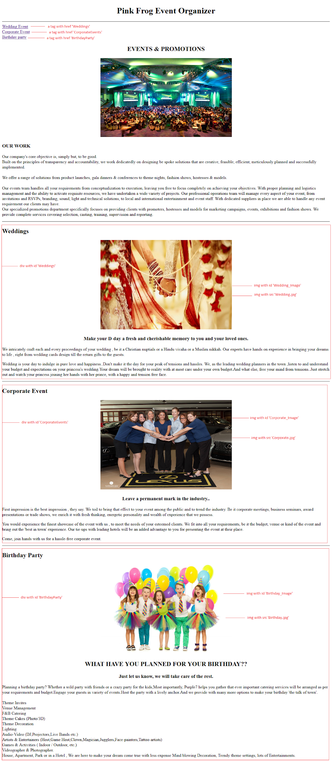

3. Links referring div ids

Jennifer, the Team Head at Maxus Events which is an event organizing company has arranged for a contest based on web designing to all her team members. Being a smart person in the tea  
m,Clara had successfully completed the task of creating a web page and in her web page the contents are displayed in the same page. But the task is when we click on a link  in the index.html page ,it should display the corresponding div element in the new page named as Event.html.  
  
Help her to complete the task by creating a webpage containing links which would refer the respective div elements on the new page as mentioned in the screenshot by using the <a> tags and <img> tags in html.

Hints :

Tag <a> The <a> tag defines a hyperlink, which is used to link from one page to another. Link to #id on different webpage - It points to the respective id of the given page.

  Syntax : <a href="different_wbpage.html #id>

Content :  
index.html  
<h1>Pink Frag Event Organizer</h1>  
<hr>  
<p>  
a tag with value - Weddings and href attribute 'Events.html#Weddings'  
a tag with value - Corporate Events and href attribute 'Events.html#CorporateEvents'  
a tag with value - Birthday Party and href attribute 'Events.html#SocialGatherings'  
img src="home.jpg"  
  
Events.html  
h1 - Pink Frag Event Organizer  
hr  
h2 - Our company's core objective is, simply but, to be good  
p - Built on the principles of transparency and accountability, we work dedicatedly on designing be spoke solutions that are creative, feasible, efficient, meticulously planned and successfully implemented.  
 We offer a range of solutions from product launches, gala dinners & conferences to theme nights, fashion shows, hostesses & models.  
img src="events.jpg"  
      
p - Our events team handles all your requirements from conceptualization to execution, leaving you free to focus completely on achieving your objectives. With proper planning and logistics management and the ability to activate requisite resources, we have undertaken a wide variety of projects. Our professional operations team will manage every aspect of your event, from invitations and RSVPs, branding, sound, light and technical solutions, to local and international entertainment and event staff. With dedicated suppliers in place we are able to handle any event requirement our clients may have.     
  
div tag with id 'Weddings'  
h3 - Weddings  
p - Pink Frag Event Organizer loves creating breath-taking, personal and luxurious weddings where every exquisite detail is beautifully presented.  
Our passionate team of wedding experts are meticulous in ensuring that every aspect of the day is seamlessly stylish, from our delectable menus to glorious flowers, venue finding and dressing, production and entertainment.  
Wedding is your day to indulge in pure love and happiness.Don't make it the day for your peak of tensions and hassles. We, as the leading wedding planners in the town ,listen to and understand your budget and expectations on your princess's wedding.Your dream will be brought to reality with at most care under your own budget.And what else, free your mind from tensions..Just stretch out and watch your princess joining her hands with her prince , with a happy and tension free face.  
img src="wedding.jpg"  
  
div tag with id 'CorporateEvents'  
h3 - Corporate Events  
p - We provide a business facilitation platform through well-researched content, which reflects the latest market trends and developments.  
Our conferences are designed to meet the ever-changing needs of the customer, with the goal of bringing industry professionals together to share their expertise, exchange ideas and facilitate business.  
The most important and valuable part of a corporate requirement is its Sales and that's coming by Brand Establishing, Promotions, Business Meet, Exhibitions and also uplifting the current profile. Get in touch with us for professional solution for your event.  
img src="Corporate.jpg"  
  
div tag with id 'SocialGatherings'  
h3 -Birthday Party  
p - Planning a birthday party? Whether a wild party with friends or a crazy party for the kids,Most importantly, Pink Frog Event Organizer helps you gather that ever important catering services will be arranged as per your requirements and budget.  
Engage your guests in variety of events.House, Apartment, Park or in a Hotel , We are here to make your dream come true with less expense Mind blowing Decoration, Trendy theme settings, lots of Entertainments.  
Host the party with a lively anchor.  
img src="birthday.jpg"  
  
Constraints :  
Tag 'a' must be present in the html page atleast 3 times.  
The links to the other pages must be properly set.  
The Content in the tags should be the same as given in the problem description.  
  
Note :  
The Webpage should be present as shown in the screenshot.  
Kindly refer the content which is given as a part of description.  
  
Sample Screenshot 1 :  
  
index.html  
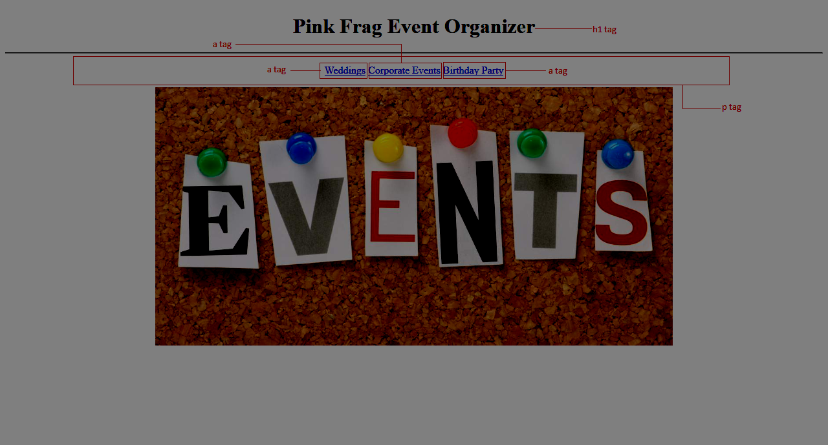

4. Links - Image gallery

Tyson, the youngest member of "RedKites creators" company is passionate towards web designing. In his leisure time, meanwhile a weekend, he designed a web page with many images those of which serves as hyperlinks to several HTML pages. His Boss liked the design idea and insisted him to develop a webpage for their popular Client Hosting Event based on his ideas. Tyson decided to incorporate his idea for the variety of Events that are hosted by his company and set out to work on the task.  
  
Tyson wanted to ease his task, hence help him to write a program to link the images with web pages using the <a> tags and <img> tags in html.

Hints :

Tag <a> The <a> tag defines a hyperlink, which is used to link from one page to another.

Syntax :   <a href = "#">...</a>

Tag <img> The <img> tag defines an image in an HTML page.

  Syntax :   <img src = "xxx.png" >

Content :  
First 'a' tag href - SocialGatherings.html  
First 'img' tag src - Birthday.jpg  
Second 'a' tag href - CorporateEvents.html  
Second 'img' tag src - Corporate.jpg  
Third 'a' tag href - Weddings.html  
Third 'img' tag src - Wedding.jpeg  
Fourth 'a' tag href - Concert.html  
Fourth 'img' tag src - Concert.jpg  
Fifth 'a' tag href - Convocation.html  
Fifth 'img' tag src - Convocation.jpg  
Sixth 'a' tag href - Farewell.html  
Sixth 'img' tag src - Farewell.jpg  
Seventh 'a' tag href - NewYear.html  
Seventh 'img' tag src - <a href="NewYear.html"><img src=""</a>

Eigth 'a' tag href - Reception.html  
Eigth 'img' tag src - Reception.jpg  
Ninth 'a' tag href - SuccessParty.html  
Ninth 'img' tag src - Successparty.jpg  
  
All .html files are given as a part of the template.

Constraints :  
First 'a' tag href attribute should be 'SocialGatherings.html'  
First 'img' tag src attribute should be 'Birthday.jpg'  
Second 'a' tag href attribute should be 'CorporateEvents.html'  
Second 'img' tag src attribute should be 'Corporate.jpg'  
Third 'a' tag href attribute should be 'Weddings.html'  
Third 'img' tag src attribute should be 'Wedding.jpeg'  
Fourth 'a' tag href attribute should be 'Concert.html'  
Fourth 'img' tag src attribute should be 'Concert.jpg'  
Fifth 'a' tag href attribute should be 'Convocation.html'  
Fifth 'img' tag src attribute should be 'Convocation.jpg'  
Sixth 'a' tag href attribute should be 'Farewell.html'  
Sixth 'img' tag src attribute should be 'Farewell.jpg'  
Seventh 'a' tag href attribute should be 'NewYear.html'  
Seventh 'img' tag src attribute should be 'NewYear.jpg'  
Eigth 'a' tag href attribute should be 'Reception.html'  
Eigth 'img' tag src attribute should be 'Reception.jpg'  
Ninth 'a' tag href attribute should be 'SuccessParty.html'  
Ninth 'img' tag src attribute should be 'SuccessParty.jpg'  
  
  
Design the webpage with all images inside a single div. Do not use table for designing the page.  
Each img should have width '300px' and height '250px'.  
  
Note :  
The Webpage should be present as shown in the screenshot.  
Kindly refer the content which is given as a part of description.  
  
  
  
Sample Screenshot 1 :  
  
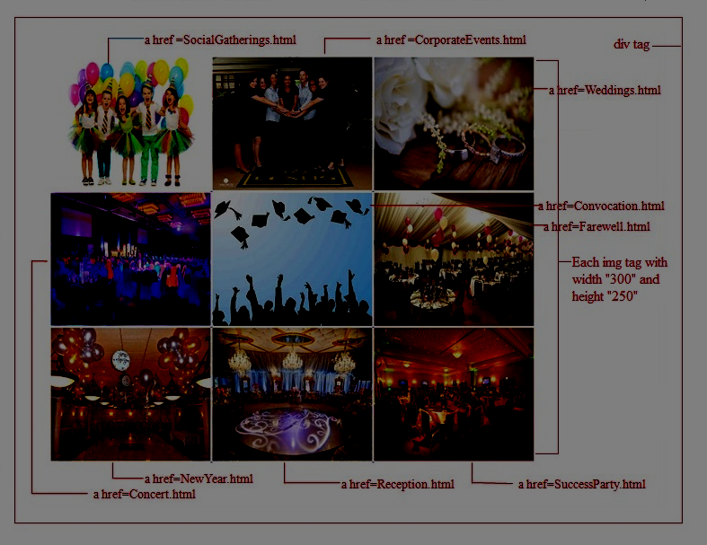  
  
Sample Screenshot 2 :  
  
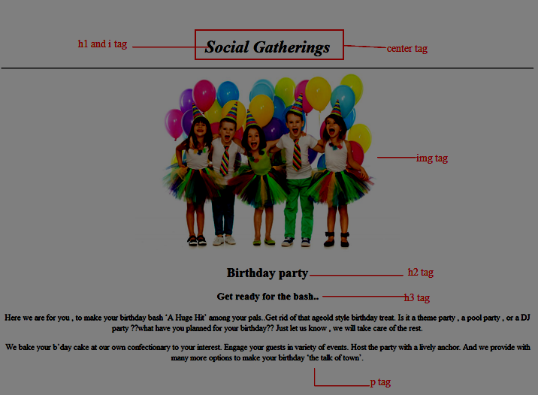  
  
  
Sample Screenshot 3 :  
  
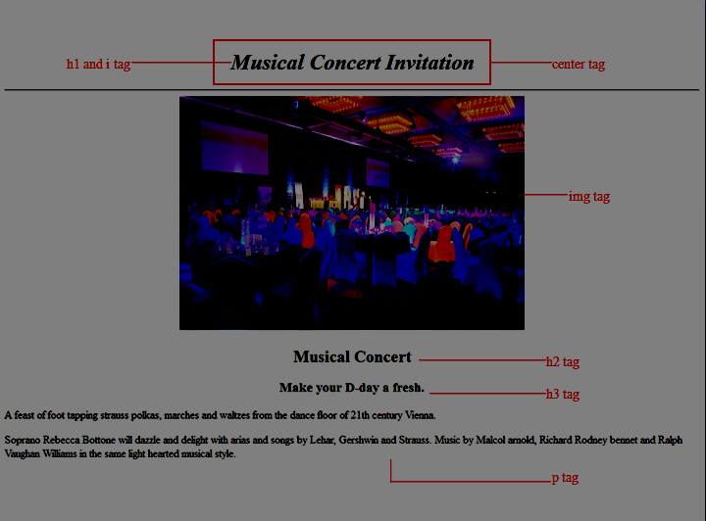  
  
Sample Screenshot 4 :  
  
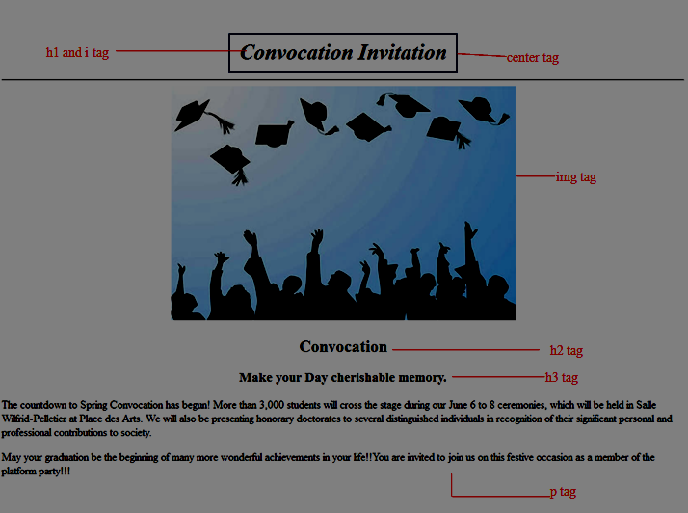  
  
Sample Screenshot 5 :  
  
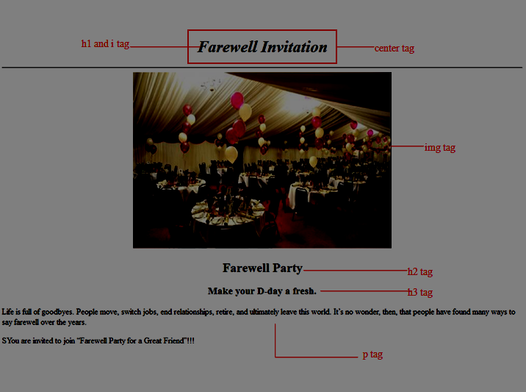  
  
Sample Screenshot 6 :  
  
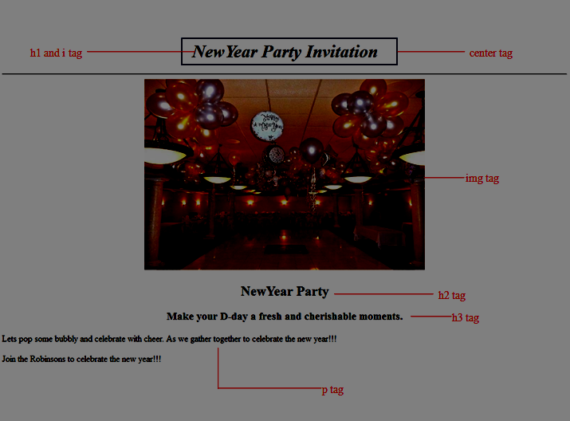  
  
Sample Screenshot 7 :  
  
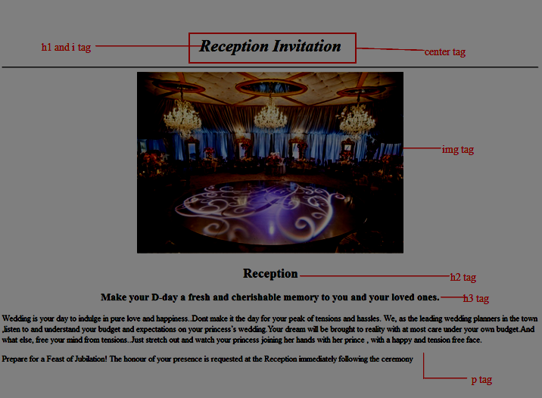  
  
Sample Screenshot 8 :  
  
